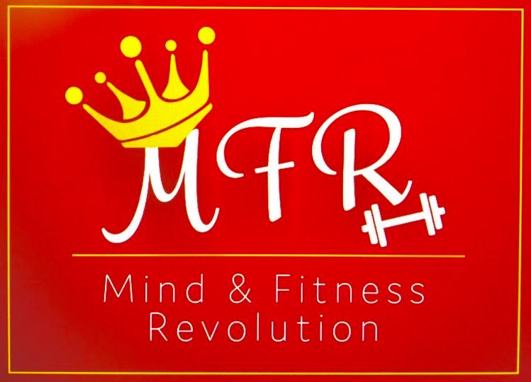

**The truth about HIIT Classes & Exercises**

**What is HIIT?**

**HIIT stands for High-Intensity Interval Training. It involves quick bursts of energy combined with a quick rest period. The workout is normally between 10-30 minutes in duration.**

**HIIT burns calories not only during the exercise but also after the exercise. After the workout, you continue to burn calories.**

**The benefits of HIIT compared with other types of exercise!**

**Physical**

* **Great if you are limited for time as it is time efficient**
* **Burns high amounts of energy**
* **Burns more fat**
* **Burns more calories**
* **Targets belly fat**
* **Get results faster**
* **Can boost brain power**
* **Great for endorphins to increase happiness & mood**
* **Improves muscle strength**

**Health**

* **Decreases the risks of getting cancer or cardiovascular disease**
* **Can lower blood pressure**
* **Can balance blood sugar levels**
* **Increases oxygen consumption**

**Quick Top Tips on HIIT**

* **Vary exercises/classes to avoid injury or over training. In other words HIIT is not suitable to do every single day (include rest days and combine with other types of exercises)**
* **Always stretch after a HIIT session to reduce the risk of injury and muscle soreness**
* **You can do HIIT with NO equipment at all**
* **HIIT is flexible as you can do it ANYWHERE! Try outdoors, at home or on the move**
* **Do a LIVE class or do a class with a family member or friend to help with motivation**

**Some Smart Facts on HIIT**

* **An average HIIT session for 20 minutes can burn over 300 calories compared with a 30 minutes 3 mile jog burning approximately 300 calories**

* **Researchers concluded that a 10 minutes HIIT workout had the same benefits as going for a 45 minutes jog**
* **Despite HIIT typically being a harder workout, studies have shown people have more fun doing HIIT workouts**
* **Studies show HIIT can help with symptoms of anxiety and depression**
* **After the HIIT workout, an additional 200 calories can be burned in the 14 hours after the workout**

**Written by CJ @ Mind & Fitness Revolution**